We write the integers of A and B (in the order they are given) on two separate horizontal lines.

Now, we may draw *connecting lines*: a straight line connecting two numbers A[i] and B[j] such that:

* A[i] == B[j];
* The line we draw does not intersect any other connecting (non-horizontal) line.

Note that a connecting lines cannot intersect even at the endpoints: each number can only belong to one connecting line.

Return the maximum number of connecting lines we can draw in this way.

**Example 1:**

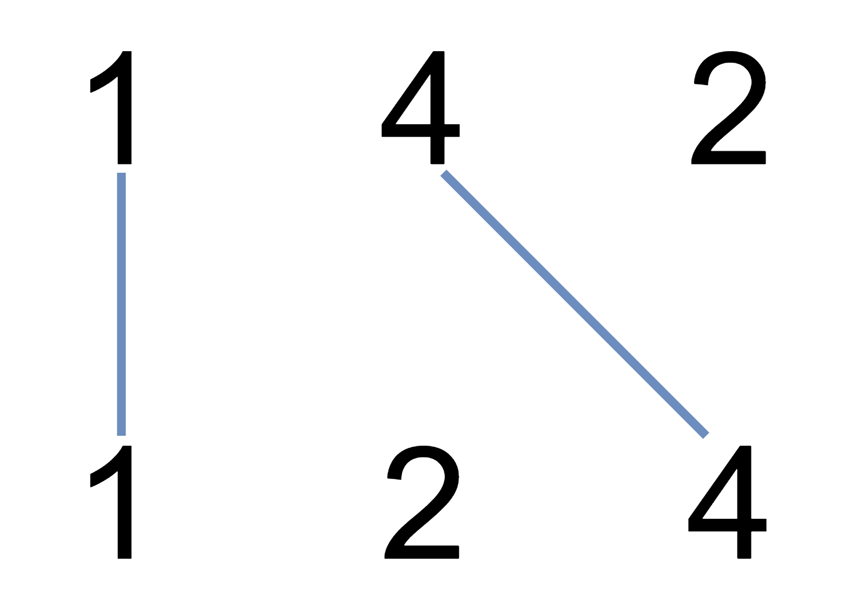

**Input:** A = [1,4,2], B = [1,2,4]

**Output:** 2

**Explanation:** We can draw 2 uncrossed lines as in the diagram.

We cannot draw 3 uncrossed lines, because the line from A[1]=4 to B[2]=4 will intersect the line from A[2]=2 to B[1]=2.

**Example 2:**

**Input:** A = [2,5,1,2,5], B = [10,5,2,1,5,2]

**Output:** 3

**Example 3:**

**Input:** A = [1,3,7,1,7,5], B = [1,9,2,5,1]

**Output:** 2

**Note:**

1. 1 <= A.length <= 500
2. 1 <= B.length <= 500
3. 1 <= A[i], B[i] <= 2000